Unit 4 AoS1: Reading and Comparing

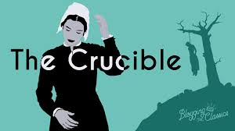

Knowledge Challenge: 13 Point Outline

Please fill in the questions below which outline your Knowledge Challenge: 13 Point Outline in detail S/N Task to be submitted via Turnitin

- Characters:
Choose the protagonist, the antagonist and your choice of 10 minor characters and complete the following details: (Note you could do this in a grid form) ie 12 characters in total

Name/Age/Interests/Work/Flaws/Conflicts/Relationships/Strengths/Struggles/ their Antagonist/Idiosyncratic features/Relatability/Other notable considerations

- Using the characters from your list above, explore the theme of power and create a continuum, listing the characters from most powerful to least powerful. For each, justify the character’s order in the continuum, including what are the views and values Miller is trying to invite the readers to consider?

- Who is your most favourite and least favourite characters and why? Quote 3 of their most significant lines and justify your choices.

- Literary Strategies: Make a list of 10 stage craft devices Miller uses and provide 3 examples that you think are effective and why?

- Setting: Provide 5 details give the play time and place and are therefore particular to Salam setting?

- Religious Terms- let’s hear it: list 10 of your choices here.

- Social and Historical Content: Research and list 10 things you discover about the HUAC, McCarthyism, the Cold War, Arthur Miller, Anti-communist propaganda, 1950s America.

- Narrative Structure & Timeline Write up a timeline of the 10 key moments in this 4 Act play: Act 1, 2, 3 & 4. Include the climactic moment and what is the resolution

- What is the Significance of the title and how does Miller use it to impact his views and values on his audience?

- What are the Key motifs (symbols) – as reflected in the title and the rest of the play & explain their significance and impact on the audience.

- How is this play and its themes still relevant today?

- Would you recommend going to see this play performed? Why? Why not?

- Who would you cast in the roles of the 12 characters you chose in question 1

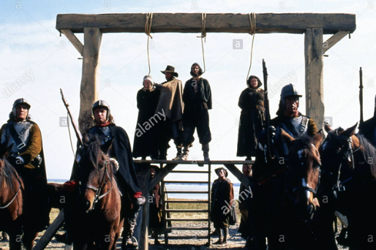

OOOOOOPS sorry, just gave away the ending

